Figure 1: <https://doi.org/10.1021/ja110964d>

Figure 2: <https://doi.org/10.1021/jp111617c>

Figure 3: <https://doi.org/10.1021/jp111617c>

Figure 4: <https://doi.org/10.1021/jp111617c>

Figure 5: <https://doi.org/10.1021/jp111617c>

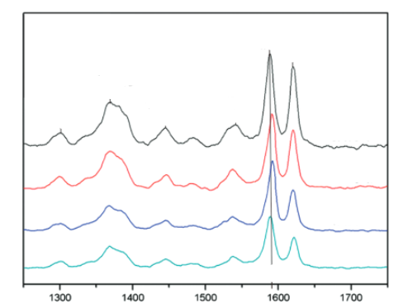

Figure 6: <https://doi.org/10.1021/jp111617c>

Figure 7: https://doi.org/10.1016/j.aca.2014.01.046

Figure 8: <https://doi.org/10.1016/j.cclet.2009.02.001>

Figure 9: <https://doi.org/10.1016/j.cclet.2009.02.001>

Figure 10: <https://doi.org/10.1016/j.cclet.2009.02.001>

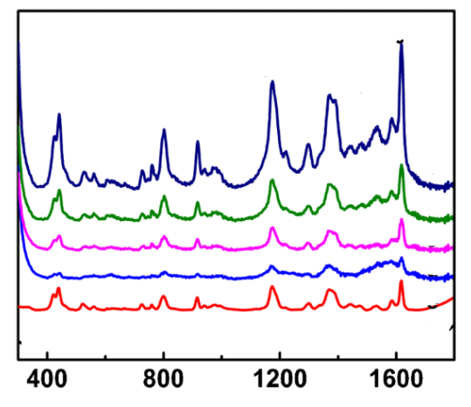

Figure 11: <https://doi.org/10.1007/s12161-014-9857-z>

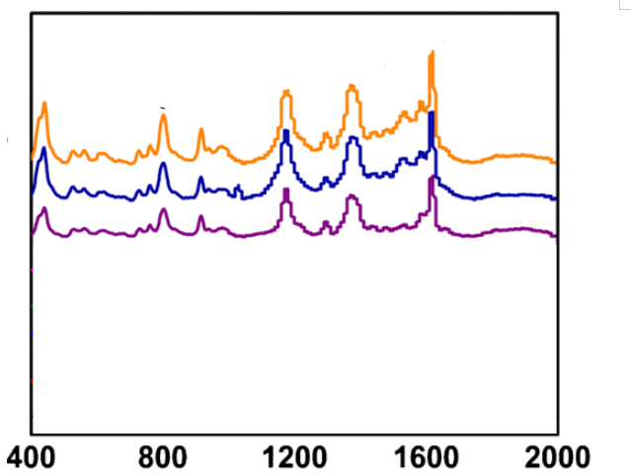

Figure 12: : <https://doi.org/10.1007/s12161-014-9857-z>

Figure 13: <https://doi.org/10.1016/j.molstruc.2012.10.066>

Figure 14: https://doi.org/10.1016/j.molstruc.2012.10.066

Figure 15: https://doi.org/10.1016/j.molstruc.2012.10.066

Figure 16: <https://doi.org/10.1016/j.molstruc.2012.10.066>

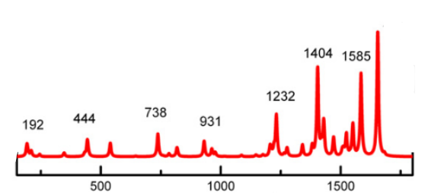

Figure 17: https://doi.org/10.1016/j.molstruc.2012.10.066

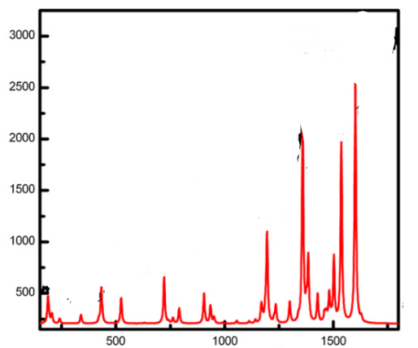Figure 18: <https://doi.org/10.1016/j.molstruc.2012.10.066>

Figure 19: <https://doi.org/10.1016/j.molstruc.2012.10.066>

Figure 20: <https://doi.org/10.1016/j.cplett.2005.08.075>

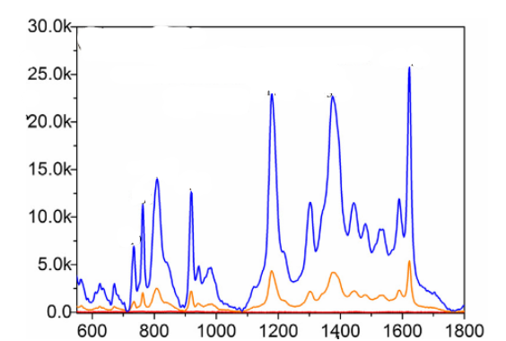

Figure 21: <https://doi.org/10.1016/j.cplett.2005.08.075>

Figure 22: <https://doi.org/10.1021/jp111617c>

Figure 23: <https://doi.org/10.1016/j.apsusc.2015.01.042>

Figure 24: <https://doi.org/10.1016/j.apsusc.2015.01.042>

Figure 25: <https://doi.org/10.1016/j.apsusc.2015.01.042>

Figure 26: <https://doi.org/10.1016/j.apsusc.2015.01.042>

Figure 27: <https://doi.org/10.1039/D1AY01107C>

Figure 28: <https://doi.org/10.1039/D1AY01107C>

Figure 29: <https://doi.org/10.1039/D1AY01107C>

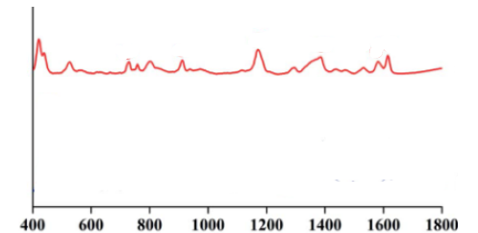

Figure 30: <https://doi.org/10.1039/D1AY01107C>

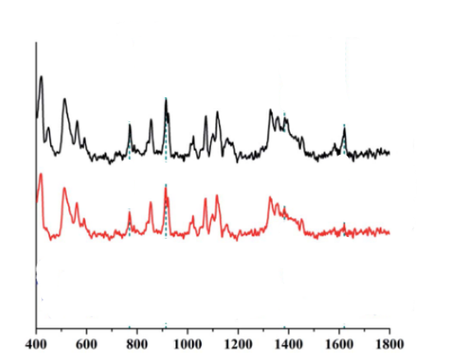

Figure 31: <https://doi.org/10.1039/D1AY01107C>

Figure 32: <https://doi.org/10.1002/jrs.5620>

Figure 33: <https://doi.org/10.1021/jp807807j>

Figure 34: <https://doi.org/10.1016/j.apsusc.2018.08.065>

Figure 35: <https://doi.org/10.1016/j.apsusc.2018.08.065>

Figure 36: <https://doi.org/10.1002/jrs.5050>

Figure 37: <https://doi.org/10.1002/jrs.5050>

Figure 38: <https://doi.org/10.1166/jnn.2013.6103>

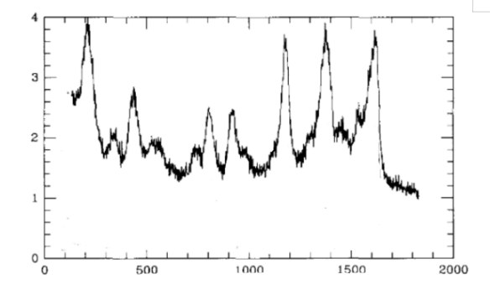

Figure 39: <https://doi.org/10.1016/0921-5107(94)01176-1>

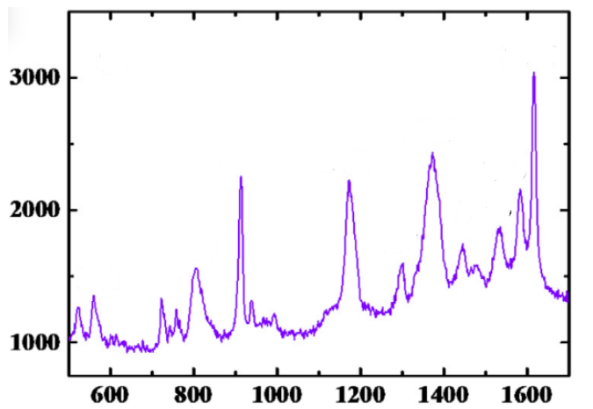Figure 40 <https://doi.org/10.1016/j.saa.2022.121165>

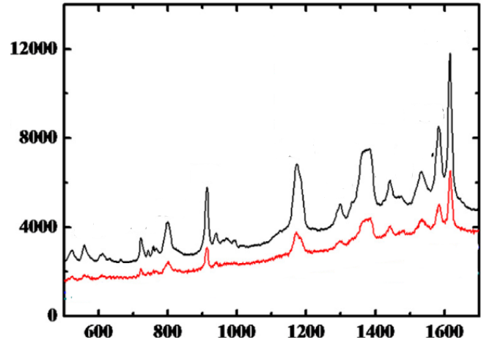Figure 41: <https://doi.org/10.1016/j.saa.2022.121165>

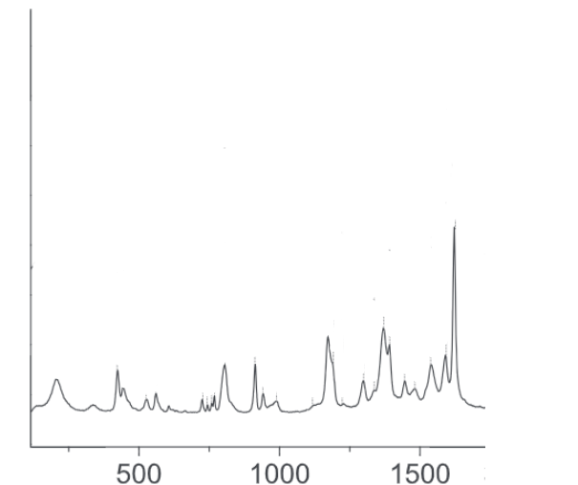

Figure 42: <https://doi.org/10.1002/jrs.5056>

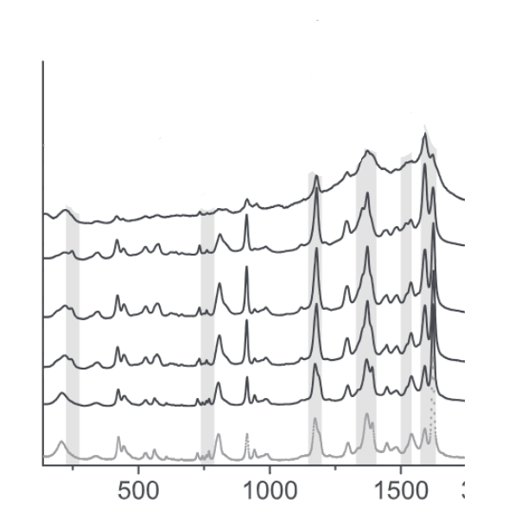

Figure 43: <https://doi.org/10.1002/jrs.5056> (gắn lại trục hoành, có thể tách 2 phổ)

Figure 43: <https://doi.org/10.1016/j.apsusc.2015.01.042>

Figure 44: https://doi.org/10.1016/j.apsusc.2015.01.042

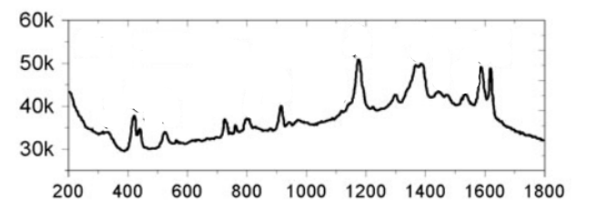

Figure 46: <https://doi.org/10.1080/09500340.2014.928378>

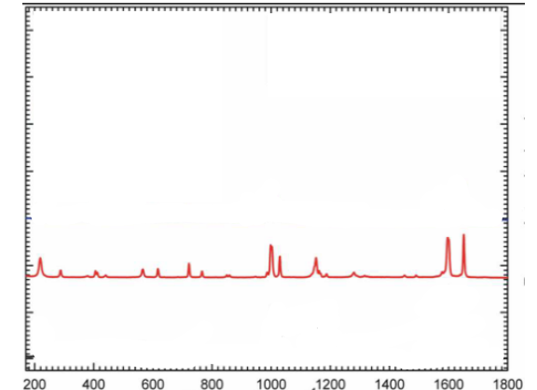**Figure 47:** <https://doi.org/10.1021/acs.cgd.5b00792>

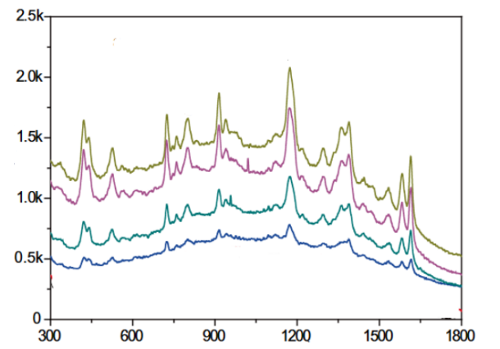

Figure 48: <https://doi.org/10.1007/s00604-020-04262-2>

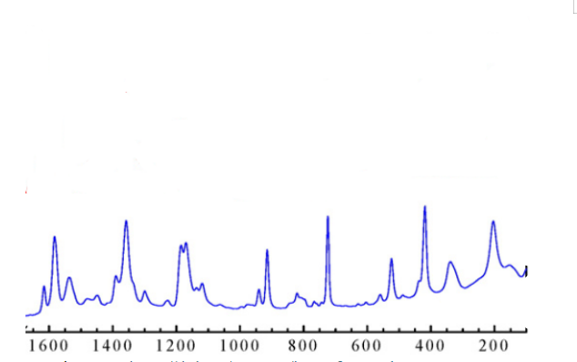Figure 49: <https://doi.org/10.1016/j.reactfunctpolym.2016.07.002>

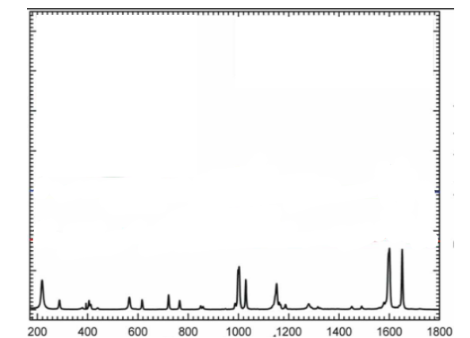

Figure 50: <https://doi.org/10.1021/acs.cgd.5b00792>

Figure 51: <https://doi.org/10.1016/j.apsusc.2019.02.072>

**Figure 52:** https://doi.org/10.1021/jp111617c

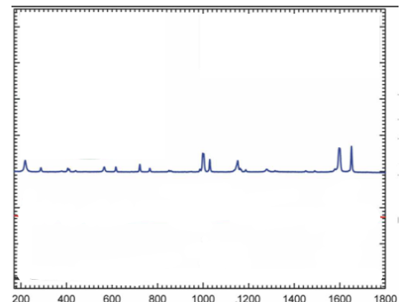

Figure 53: <https://doi.org/10.1021/acs.cgd.5b00792>

Figure 54: <https://doi.org/10.1039/D1MA01181B>

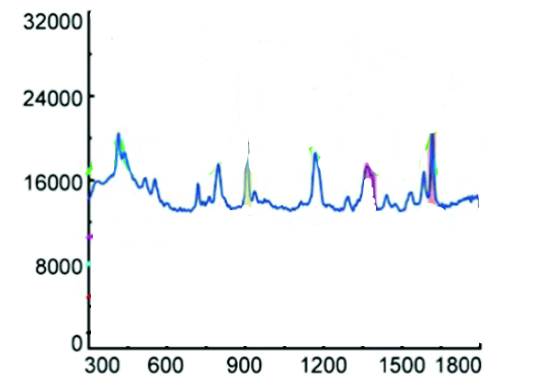

Figure 55: <https://doi.org/10.1039/D1MA01181B>

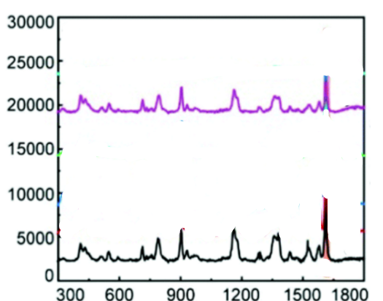

Figure 56: <https://doi.org/10.1039/D1MA01181B>

Figure 57: <https://doi.org/10.1039/D1MA01181B>

Figure 58: <https://doi.org/10.1016/j.snb.2014.03.091>

Figure 59: <https://doi.org/10.1016/j.snb.2014.03.091>

Figure 60: <https://doi.org/10.1016/j.snb.2014.03.091>

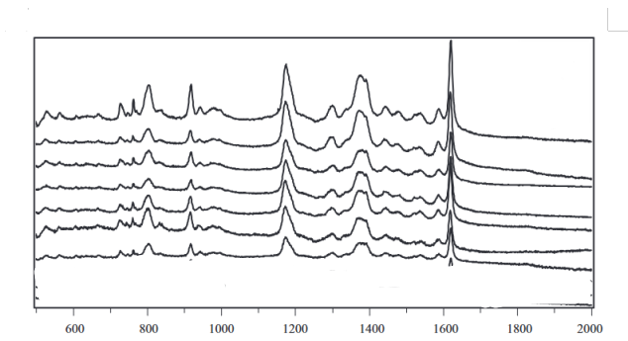

Figure 61: <https://doi.org/10.1016/j.snb.2014.03.091>

Figure 62: <https://doi.org/10.4028/www.scientific.net/AMR.936.1989>

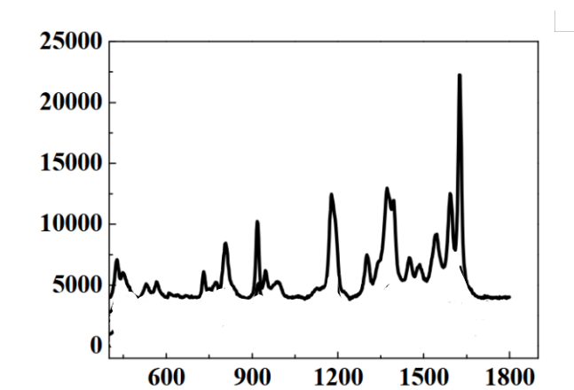

Figure 63: <https://doi.org/10.4028/www.scientific.net/AMR.936.1989>

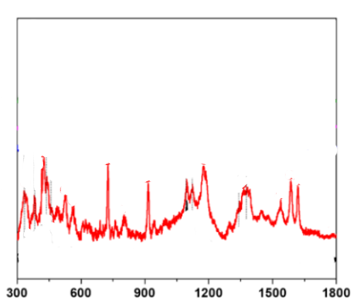

Figure 64: <https://doi.org/10.4491/eer.2021.643>

Figure 65: <https://doi.org/10.1039/A904367E>

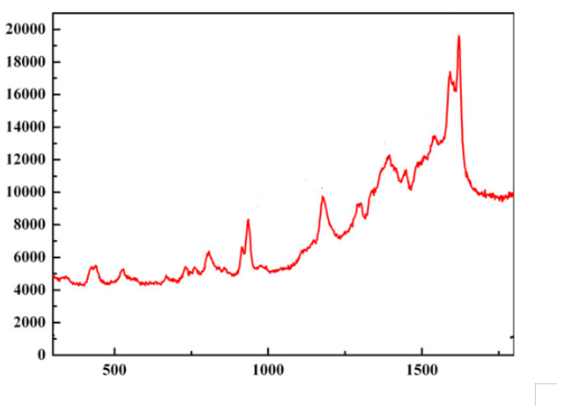

Figure 66: <https://doi.org/10.1016/j.molstruc.2012.04.043>

Figure 67: <https://doi.org/10.4028/www.scientific.net/AMM.299.191>

Figure 68: https://doi.org/10.1021/jp111617c

Figure 69: https://doi.org/10.1021/jp111617c

**Figure 70:** https://doi.org/10.1016/j.apsusc.2015.01.042

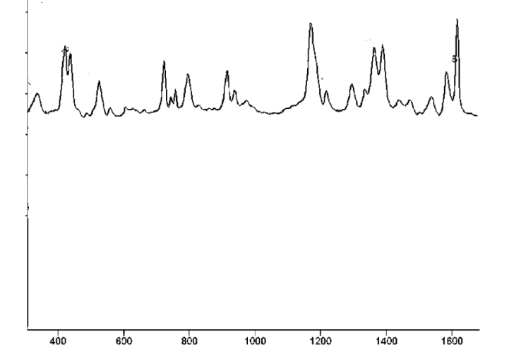Figure 71: <https://doi.org/10.1021/jf801969v>

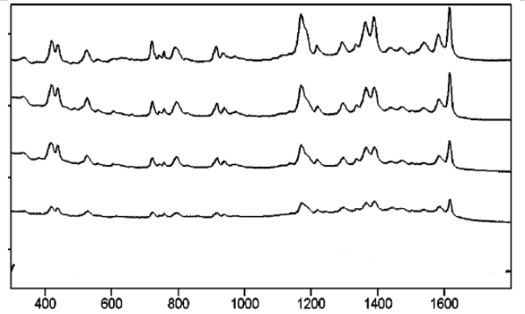Figure 72: <https://doi.org/10.1021/jf801969v>

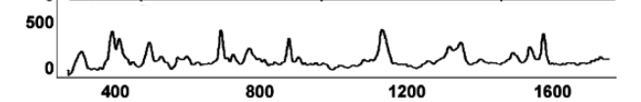

Figure 73: <https://doi.org/10.1021/jf801969v>

Figure 74: <https://doi.org/10.1016/j.saa.2017.11.062>

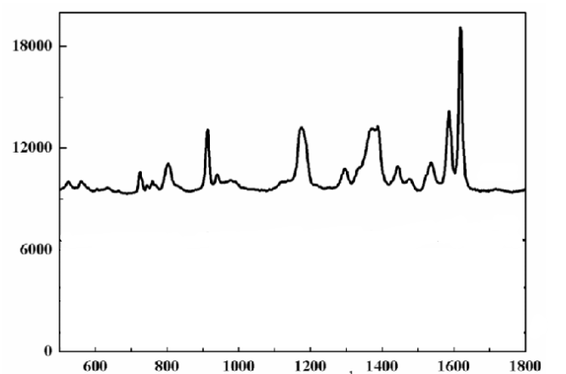Figure 75: <https://doi.org/10.1016/j.saa.2017.11.062>

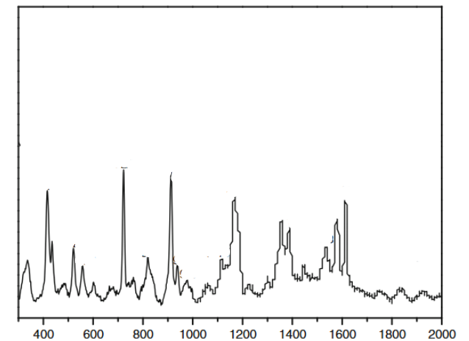

Figure 76: <https://doi.org/10.1007/s11694-011-9106-8>

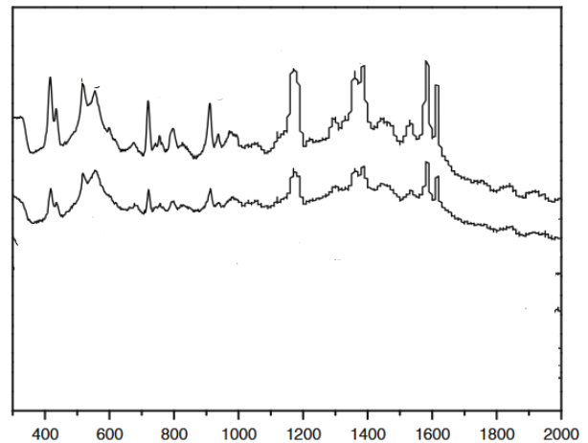

Figure 77: <https://doi.org/10.1007/s11694-011-9106-8>

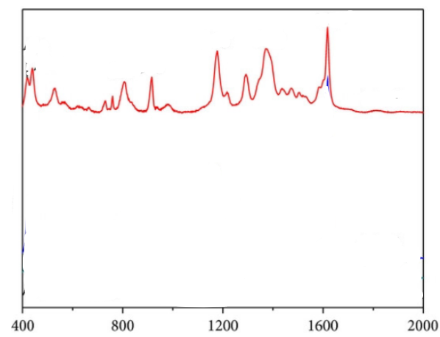

Figure 78: <https://doi.org/10.1155/2014/730915>

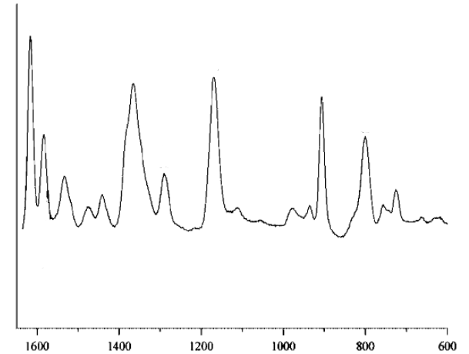

Figure 79: <https://doi.org/10.1002/jrs.1333>

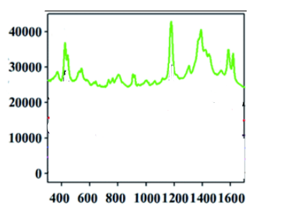

Figure 80: <https://doi.org/10.1039/C7RA05567F>

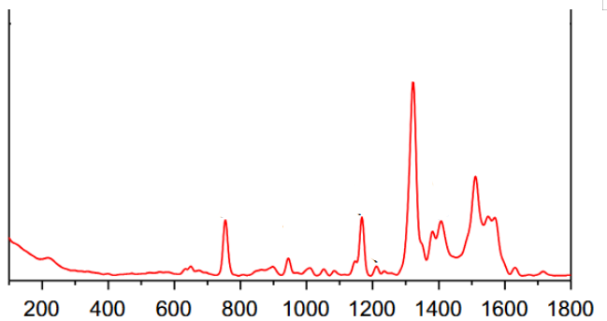

Figure 81: <https://doi.org/10.1016/j.matchemphys.2012.10.022>

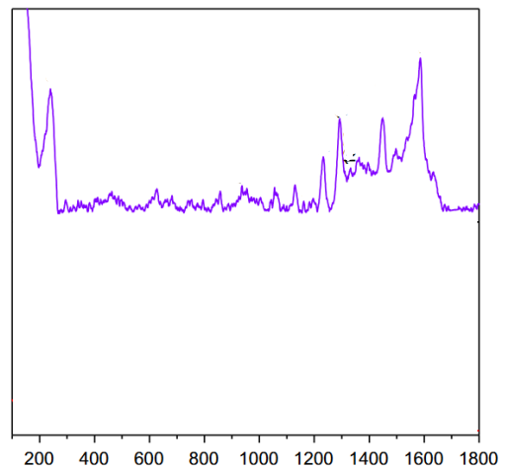

Figure 82: <https://doi.org/10.1016/j.matchemphys.2012.10.022>

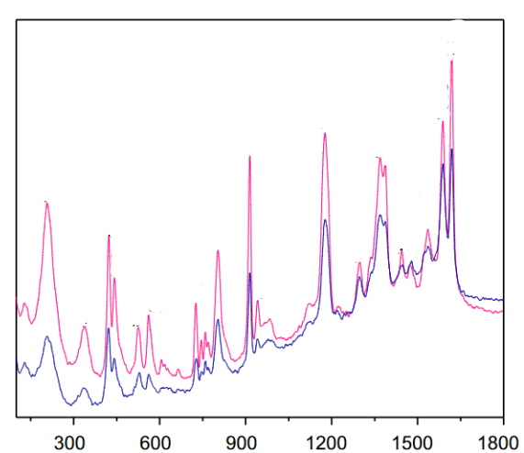

Figure 83: <https://doi.org/10.1016/j.matchemphys.2012.10.022>

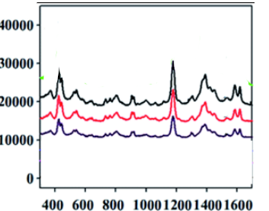

Figure 84: <https://doi.org/10.1039/C7RA05567F>

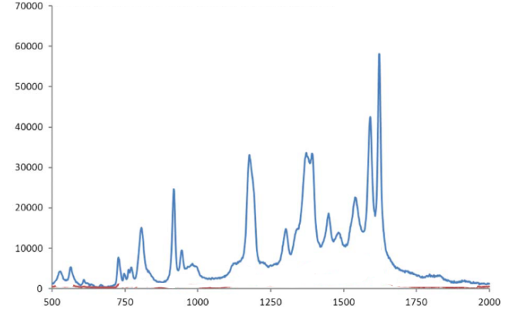Figure 85: <https://doi.org/10.1039/C1RA00827G>

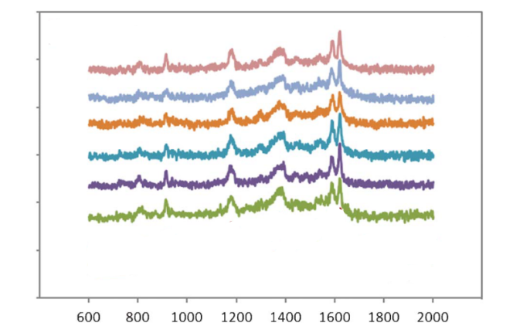Figure 86: <https://doi.org/10.1039/C1RA00827G>

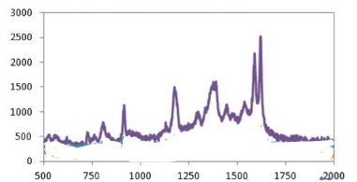

Figure 87: <https://doi.org/10.1039/C1RA00827G>

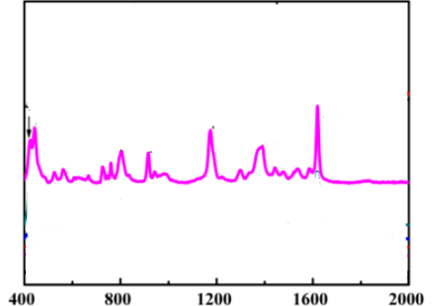

Figure 88:<https://doi.org/10.3390/nano6090175>

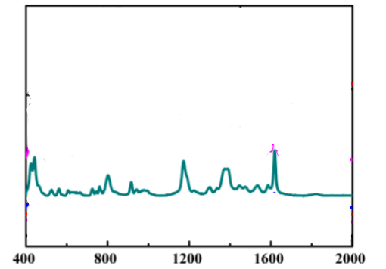

Figure 89: <https://doi.org/10.3390/nano6090175>

Figure 90: <https://doi.org/10.1039/D4NR03299C>

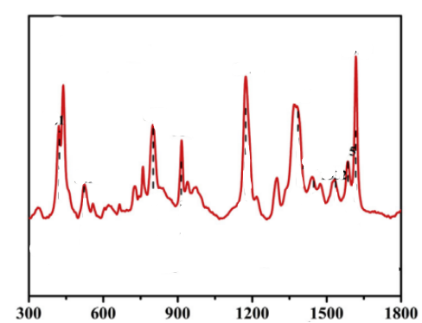

Figure 91: <https://doi.org/10.1016/j.aca.2016.04.002>

Figure 92: <https://doi.org/10.1016/j.aca.2016.04.002>

Figure 93: <https://doi.org/10.1016/j.aca.2016.04.002>

Figure 94: <https://doi.org/10.1016/j.aca.2016.04.002>

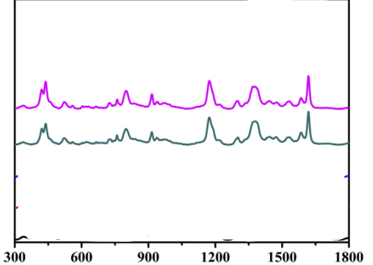

Figure 95: <https://doi.org/10.1016/j.aca.2016.04.002>

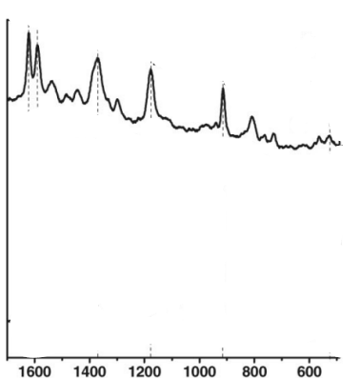

Figure 96: <https://doi.org/10.1002/jrs.1639>

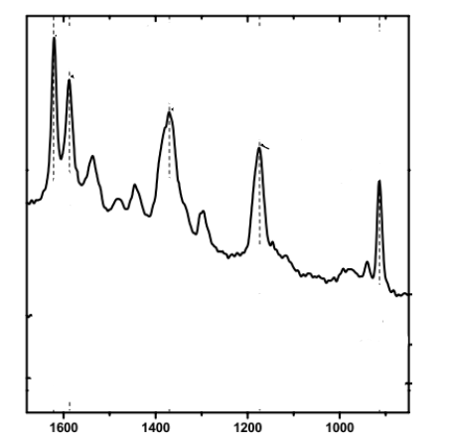

Figure 97: <https://doi.org/10.1002/jrs.1639>

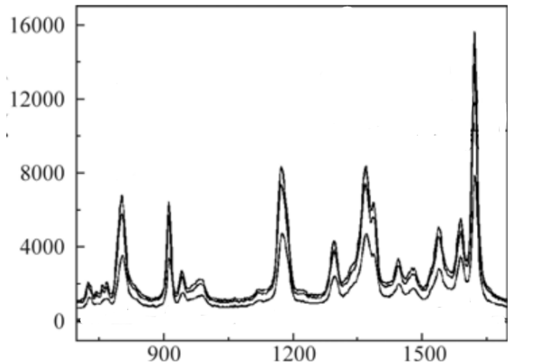

Figure 98: <https://doi.org/10.1007/s11801-013-3077-4>

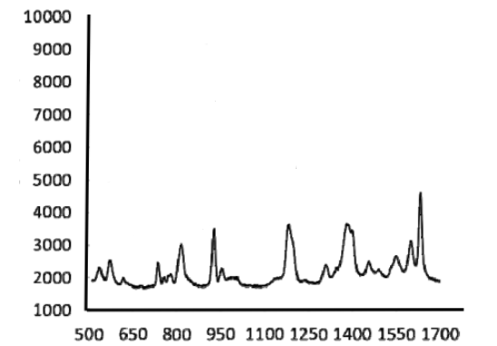

Figure 99: <https://doi.org/10.1117/12.874755>

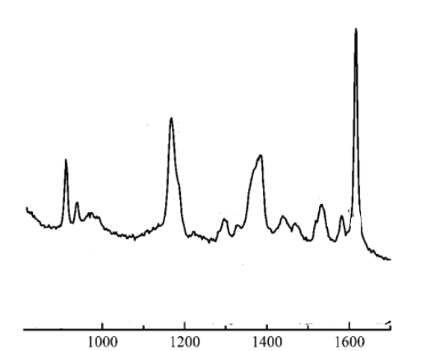

Figure 100: <https://doi.org/10.1021/ac801431m>

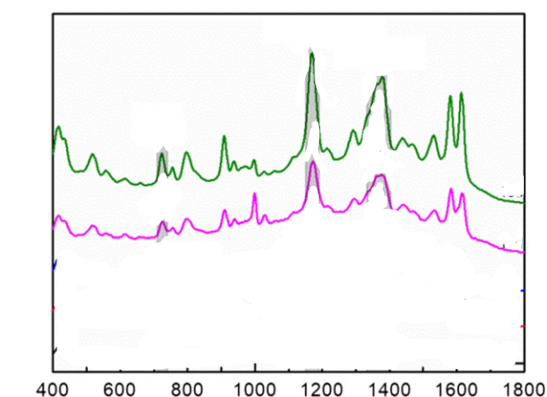

Figure 101: <https://doi.org/10.1007/s12161-020-01792-6>

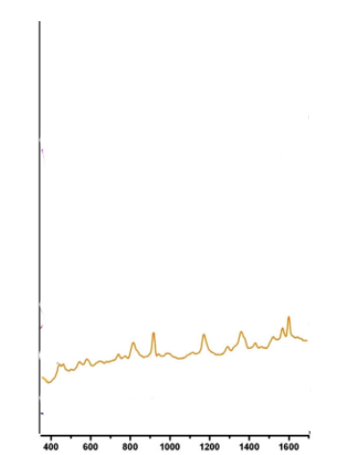

Figure 102: <https://doi.org/10.1016/j.saa.2012.09.055>

Figure 103: <https://doi.org/10.1016/j.carbon.2013.03.043>

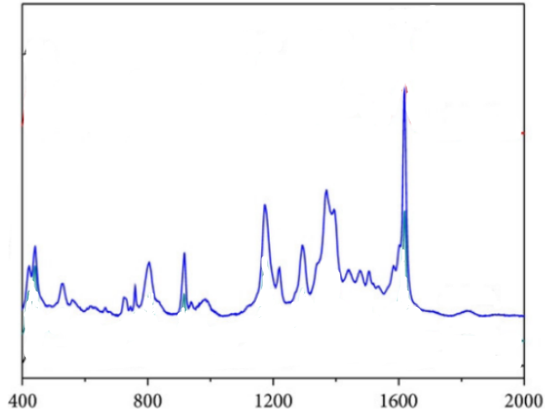

Figure 104: <https://doi.org/10.1155/2014/730915>

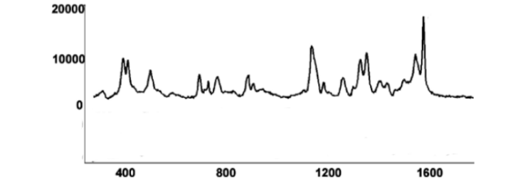

Figure 105: <https://doi.org/10.1021/jf801969v>

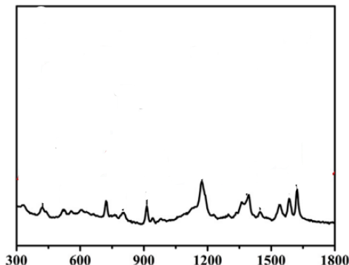

Figure 106: <https://doi.org/10.1016/j.aca.2016.04.002>

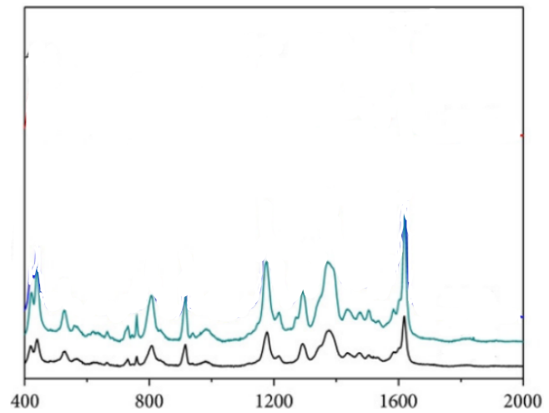

Figure 107: <https://doi.org/10.1155/2014/730915>

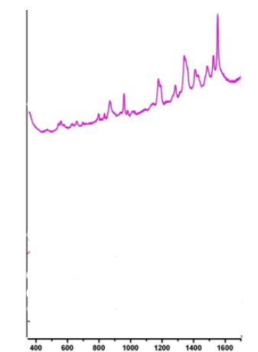

Figure 108: <https://doi.org/10.1016/j.saa.2012.09.055>

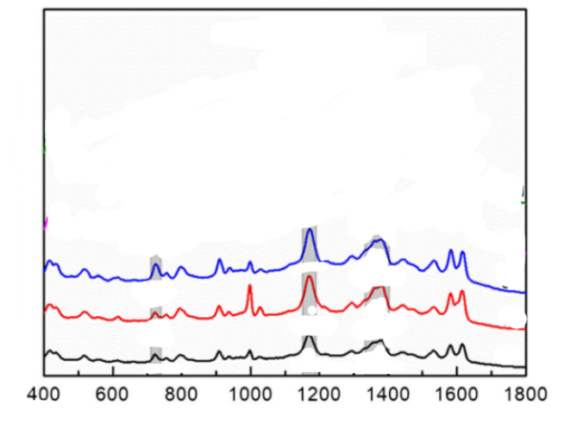

Figure 109: <https://doi.org/10.1007/s12161-020-01792-6>

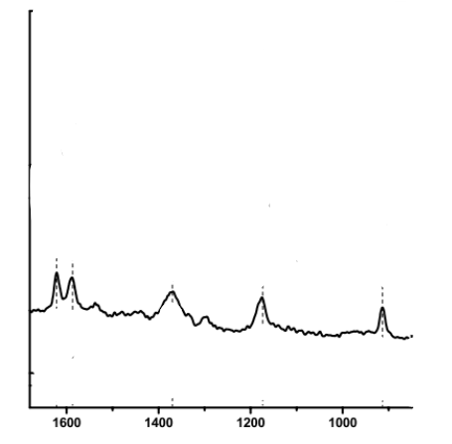

Figure 110: <https://doi.org/10.1002/jrs.1639>

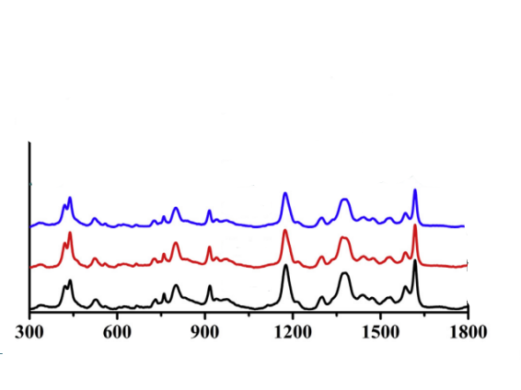

Figure 111: <https://doi.org/10.1016/j.aca.2016.04.002>